**ORCID Instructions**

The Office of Contracts and Grants at CU Boulder has pulled together and highlighted information about ORCID in an effort to assist CU Boulder’s research community. If you have questions or need assistance, please contact your [OCG Proposal Analyst](https://www.colorado.edu/ocg/directory/).

**Information about CU and ORCID:** [**https://www.colorado.edu/fis/ORCID**](https://www.colorado.edu/fis/orcid)

**What is ORCID?**

**O**pen **R**esearcher and **C**ontributor **ID**entifier

ORCID is a “non-profit, community-driven effort to create and maintain a registry of unique researcher identifiers and a transparent method of linking research activities and outputs to these identifiers” ([http://ORCID.org/content/initiative](http://orcid.org/content/initiative)).

**Why ORCID?**

It is currently very difficult to:

* Track different forms of an individual researcher’s name across systems;
* Distinguish between different researchers with the same name;
* Identify all scholarly works associated with a particular researcher.
* These difficulties may lead to faculty not receiving attribution for the full range of their scholarly contributions. ORCID attempts to solve this problem by creating unique faculty ids that can be linked to existing identifiers as well as things like journal publisher manuscript submission systems, funding agency grant application workflows, and other tools.
* Unlike other identifier systems, ORCID is open and community-driven, and reaches across disciplines, geographic regions, and types of content held by publishers, journals, and funding agencies to include all types of scholarly works (e.g., articles, books, data sets, grants, software, etc.).

**Who is using ORCID?**

ORCID has been adopted and integrated by hundreds of universities, funding agencies, publishers, data repositories, and others. Required ORCID registration is being phased in by NIH beginning in October 2019, starting with institutional research training, career development and other research education awards. NSF and other federal agencies are planning to require ScienCV-built Biosketches. ScienCV is designed to use ORCID to populate most of the required fields.

**Signing up for ORCID**

* CU Boulder created ORCID iDs for all tenure-track faculty, instructors, clinical faculty and research faculty in two registrations during 2014 and 2016, so many of our people already have IDs.
* If you are a current faculty member needing an ORCID iD, please register for an ORCID iD using your Colorado.edu email address at [https://ORCID.org/register](https://orcid.org/register).
* When you have received your new ORCID iD, please send it to [ORCID-support@colorado.edu](mailto:orcid-support@colorado.edu) for inclusion in the CU Boulder ORCID database. Your new ORCID iD will show on your FRPA and CU Experts profile within a couple of business days. The new campus ORCID registration process (expected in late 2019 or early 2020) will simplify this process to flow to data systems automatically.
* If you previously registered for an ORCID iD, but it is not showing on your FRPA, please email your ORCID iD to [ORCID-support@colorado.edu](mailto:orcid-support@colorado.edu?subject=My%20ORCID%20iD). Your ORCID iD will show on your FRPA and CU Experts profile within a couple of business days.

**Step-by-step registration and account setup**

1. An ORCID iD is a 16 digit unique identifier, for example, 0000-0002-1825-0097.

If you think you’ve registered for ORCID, but don’t remember your ID or user name, try the following steps to find your ORCID iD.

* 1. Go to [CU Experts](https://experts.colorado.edu/) , and search by your name. Once you’ve located and opened your record, scroll down to the Other Profiles section. If you have an ORCID iD that has been associated with CU, it will be listed there; if you click on your iD it will take you to your ORCID biography page, and you can login from there;
  2. Look up your name in the search bar on the main page of the ORCID website (or use the advanced search functionality at <https://orcid.org/orcid-search/search>). If your profile is in any way populated and the information is set to visible - you will be able to identify yourself and see your ORCID iD.
  3. Go to <https://orcid.org/signin> and enter the email address you think might be associated with your ORCID account, and select the “Forgotten your password? Reset it here” option. ORCID will send an email to that address with either a link to reset the password, or notification that the email address is not registered

1. If you don’t have an existing ID, register through the ORCID website, [https://ORCID.org/register](https://orcid.org/register) ,

or if you’re already registered, login at [https://ORCID.org/signin](https://orcid.org/signin)

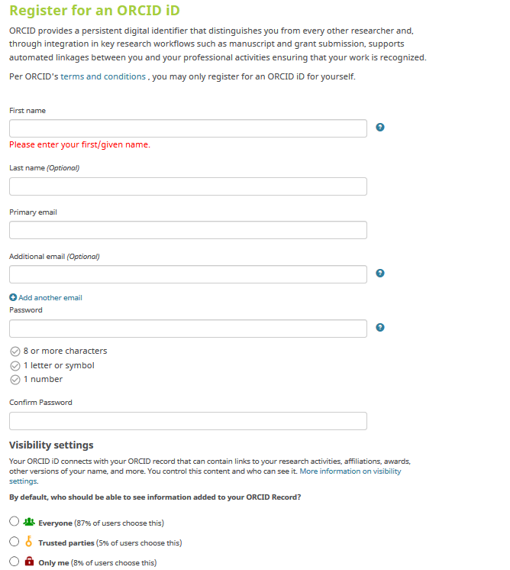

Pick either Trusted Parties or Everyone.

1. Follow emailed verification instructions

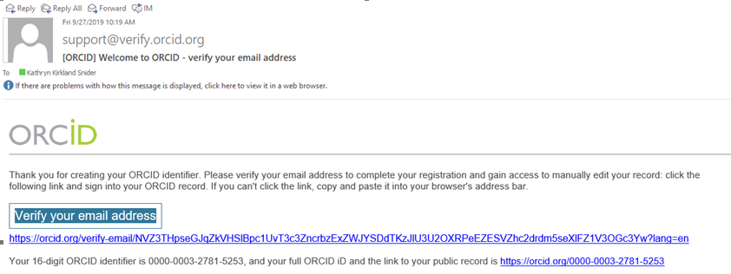

1. Send your new ORCID iD to [orcid-support@colorado.edu](mailto:orcid-support@colorado.edu) for inclusion in the CU Boulder ORCID database. Your new ORCID iD will show on your FRPA and CU Experts profile within a couple of business days.

5a. Complete the Biography section

Make sure this is **set to Trusted Parties or Everyone**.

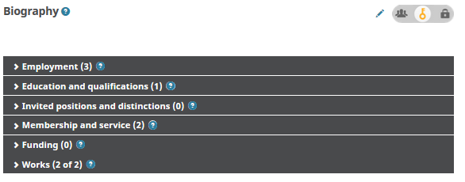

Information is manually entered for these four sections.

In these two sections, information can be entered manually or through linking (see instructions below) .

5b. Complete the Funding section – importing

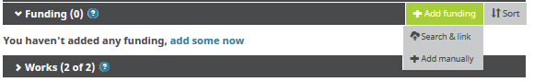

Select **Search & link**, and then **click on the UberWizard** link.

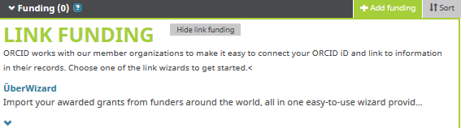

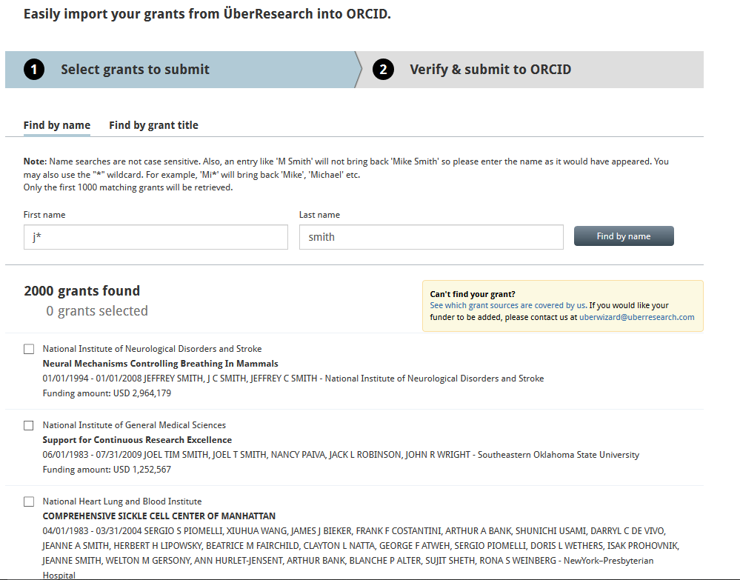

**Check the boxes** for the grants you want to import into ORCID.

Enter your name, **click on the Find by name** button.



Once you’ve selected all of your grants, **click on Next**.

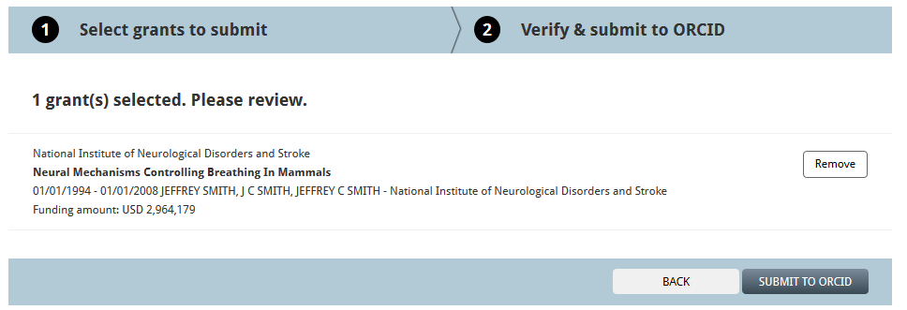

Verify your grants, and **click on Submit to ORCID**. The grants will be imported to your ORCID account – you may need to close and re-open your ORCID account to see the additions.

5c. Completing the Funding section – manually entering

**Select Add manually**, fill out, **set visibility** to Trusted Parties or Everyone, **select Add to list**.



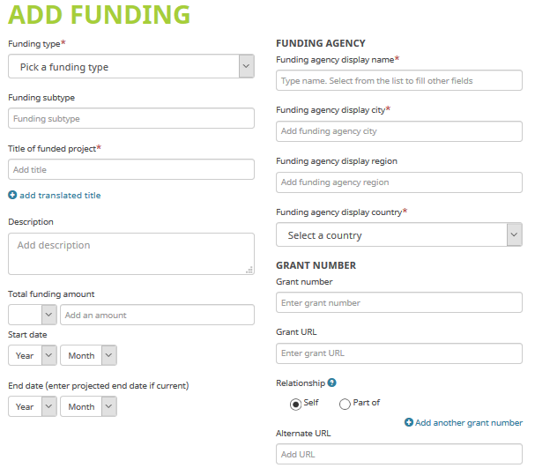



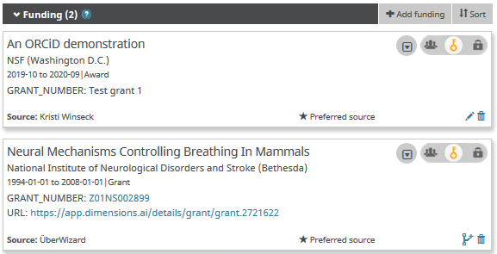

This is how the funding list will appear on your ORCID Biography page.

5d. Completing the Works section – importing

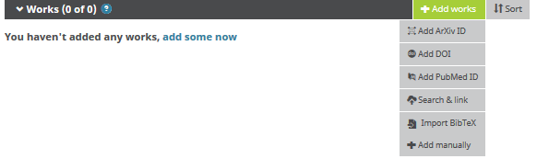

Publication lists can be **exported from CUBE** for upload in the BibTex format. [Learn more](https://www.colorado.edu/fis/sites/default/files/attached-files/exporting_publication_data_from_elements_-_screenshot_0.pdf)

or contact Matt Ramey at [pubsdata@colorado.edu](mailto:pubsdata@colorado.edu) for more information on using CUBE to populate your ORCID works section.

For Add manually, fill out, **set visibility** to Trusted Parties or Everyone, **select Add to list**.

For the Import options, **click on the appropriate choice**, and follow the instructions.

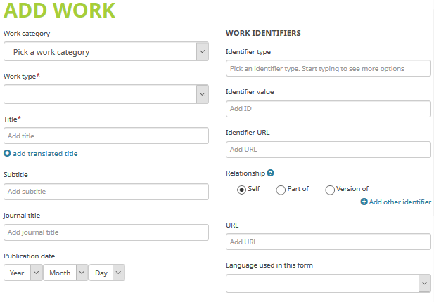

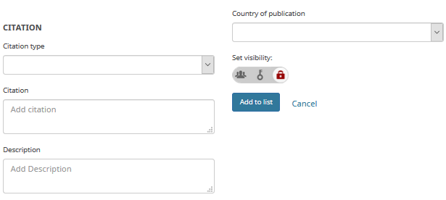

**Associate your Sponsor-specific ID with ORCID**

1. NIH

1a. Sign in: <https://public.era.nih.gov/commons/public/login.do>

1b. Access your Personal Profile

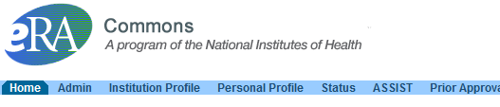

1c. Connect to ORCID

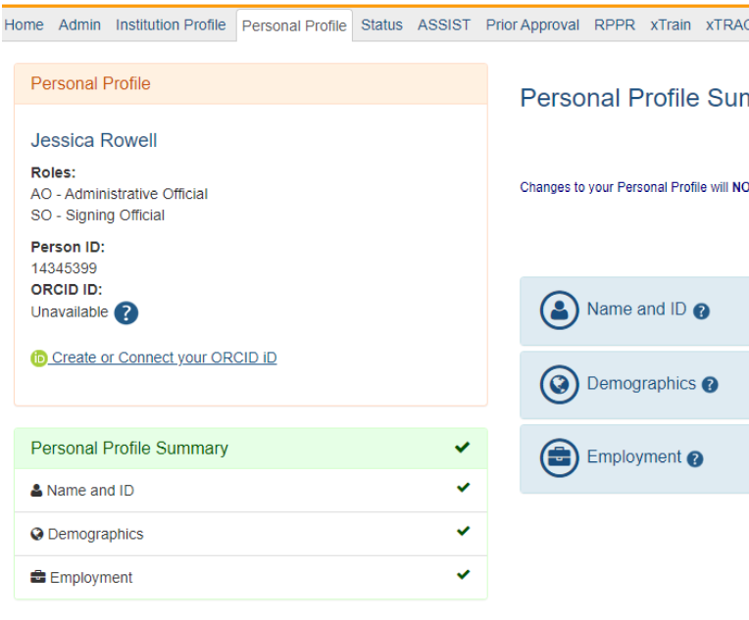 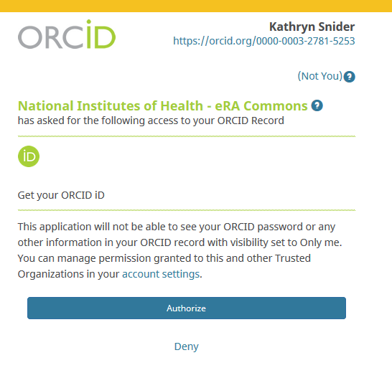

On the left sidebar, **follow the link** to connect your ORCID and authorize the access.

1. NSF (Research.gov)

2a. Sign in: <https://www.research.gov/research-web/>

2b. Access My Profile



2c.

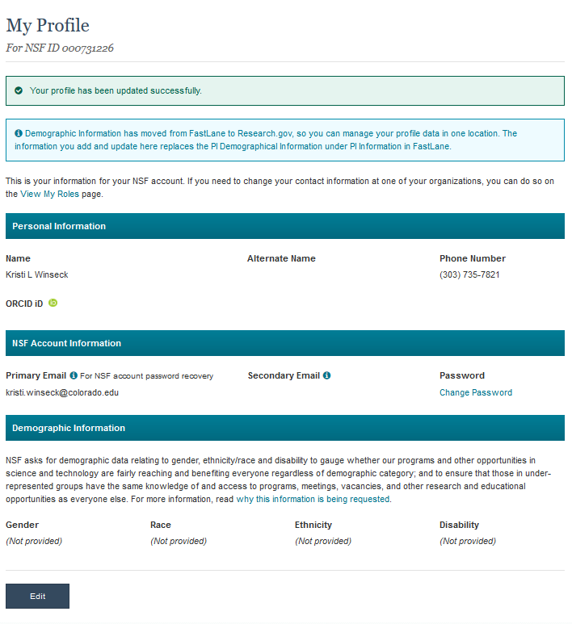 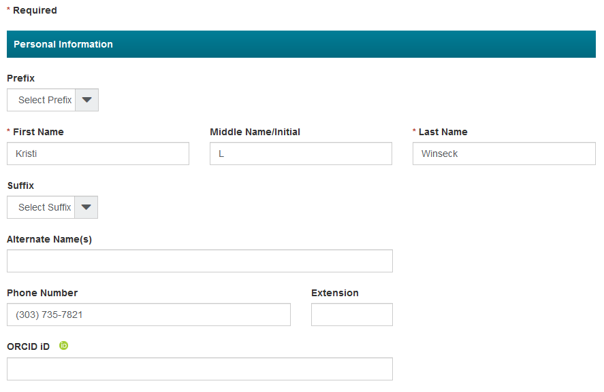

**Select Edit**, **enter** your ORCID iD, and **select Save** at the bottom of the screen.

1. Proposal Central

Note that to import your ORCID information to Proposal Central, your ORCID visibility settings need to be **set to Everyone**

3a. Sign in: <https://proposalcentral.com/default.asp>

3b. Access your Professional Profile

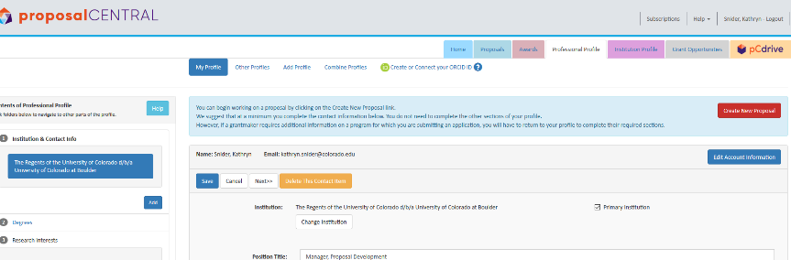

Then **follow the link** to connect your ORCID iD and authorize the access. See the NIH section above for authorization instructions.

3c. Select which information you want to import from ORCID

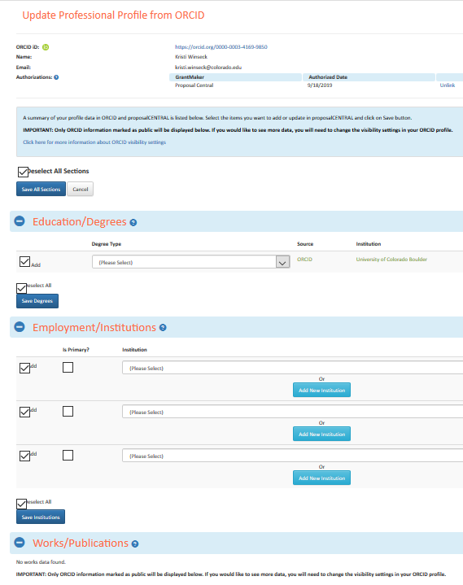

After you’ve chosen the sections to add, **select Save All**. **Sections**

**Choose** either **the sections** you want updated from ORCID **or Select All**.