Pre- to Post-Award Handoff

Purpose

These work instructions will provide student workers with guidance for locating information in ERA that will be recorded in the Pre-Award to Post-Award Handoff Checklist. The checklist will be provided to post-award department personnel to assist the PI’s unit with better management of day-to-day post-award tasks.

Using the Navigation Pane

To use the Navigation Pane in Word, click on the tab at the top of this document. Check the box for under the Show section.

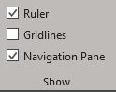

To jump from one section of the document to another using the Navigation Pane, just click on the section you want to view in the pane.

Award Information

The information necessary to complete the Award Information section of the Pre-Award to Post-Award Handoff Checklist is found in a variety of locations between the proposal site and the award site. Instructions of where to locate each piece of information is detailed below.

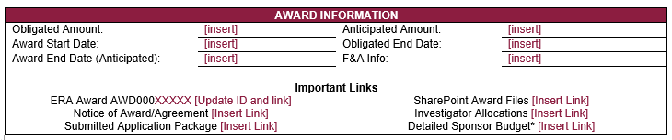

Submitted Application Package

To locate the submitted application package, navigate to the Funding Proposal (FP) through the system notification provided. Scroll almost to the end of the FP. The application package will be found within the 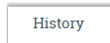 tab below 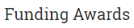.

Navigate through the pages until you find which marks that the proposal has been submitted to the sponsor. This history message will include a confirmation that the sponsor received the submission and a copy of the submitted proposal.

Copy the link to the submitted proposal by right-clicking on the link and selecting Copy Link Address.

In the email template, right-click the and click Link. Paste the browser link and press OK. This will allow the unit to navigate directly to the submitted application package.

ERA Award

On the 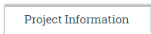 tab of the FP, scroll approximately halfway towards the bottom of the page to a subtitle called . This will include all awards attached to this proposal.

In this section, click on the blue linked name.
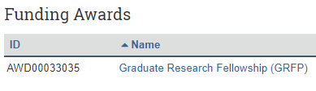

This will take you to the main award page. The purple Award ID is in the top right corner of the main award page.
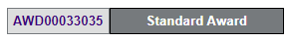

Copy this AWD number and paste into the email template found in the same folder as these work instructions.

Copy the browser link provided on this main page. Using the same method as above, link the award page browser link to the AWD number in the email template.

Notice of Award/Agreement

On the 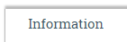 tab of the Award, scroll towards the bottom of the page. Click on the 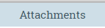 tab. This tab will include all of the award documents including the terms and conditions.

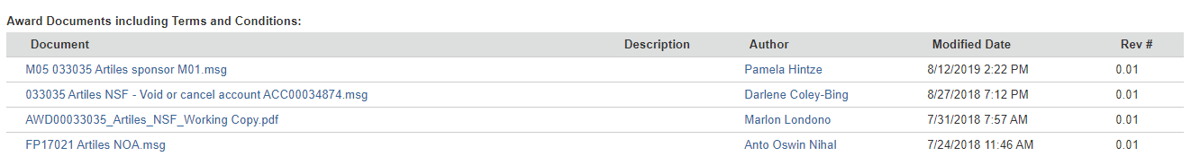

Right-click the to open the document in a new tab. Using the same method as above, link the Notice of Award document to the section of the email template.

SharePoint Award Files

Within the main award page on the left-hand side, there will be a link to the Awards SharePoint.
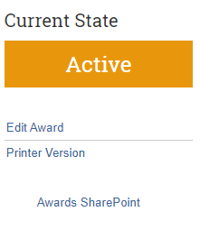

Right-click this link and select Copy Link Address. In the email template, right-click and link the SharePoint files web address to this text using the method above.

Obligated Amount

Under the section under the 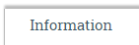 tab, the current Obligated amount for the award is listed.

Copy and paste this figure into the section of the email template.

Anticipated Amount

Within the section, the Anticipated amount is listed.

Copy and paste this figure into the section of the email template.

Award Start Date, Award End Date (Anticipated) and Obligated End Date

Within the section, the Award Start Date, Obligated End Date and Award End Date (Anticipated) is listed.

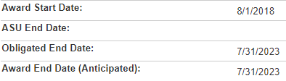

Copy and paste these figures into the Award Start Date, Award End Date (Anticipated), and Obligated End Date sections of the email template as shown below.

Investigator Allocations

Under the Current State label on the main award page, click View Award. Click on located at the top of the smart form. Select 6.0 Lead Unit Investigator Allocations.

Select the link provided in the browser, right-click and select Copy. Link into the area of the email template using the method above. Click to leave the award smart form.

Detailed Sponsor Budget

Navigate back to the proposal site by scrolling to the section and clicking on the proposal Name. Under the section, click on the Name of the budget. This will take you to the budget for the proposal.

Click on the 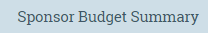 tab which will provide you with a detailed sponsor budget.

Select the link provided in the browser, copy and link into the section of the email template using the method above.

F&A Info

Within the budget section of the proposal site, click on . Using the function, select 1.2 F&A Rate Determination.

Select the link provided in the browser, copy and link into the section of the email template using the method above.

Account Information

Most of the information for the Account Information section of the email template can be found via the main award page of the AWD account.

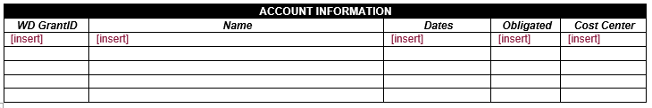

On the main award AWD page, scroll to the 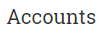section.

WD GrantID

The WD GrantID is the last 5 digits of the ACC number with the “ACC000” at the beginning replaced with “GR”. For example, would become GR35088.

Name

The Name is found to the right of the Account number. For example, the name for ACC00035088 would be “Graduate Research Fellowship – GRFP”.

Dates

The Dates would include the Start Date and the End Date found to the right of the Name next to Lead Financial Unit. For ACC00035088, the start and end dates would be 8/1/2018 – 7/31/2023.

Obligated

The Obligated amount that is currently in the account can be found to the right of the End Date. For ACC00035088, the obligated amount is $2,703,167.

Cost Center

To locate the Cost Center, we will need to navigate into the Account. To do this, click on the ACC number listed under . Then, click on found under the Current State on the left-hand side of the page. Under the section, the Workday Cost Center can be located in subsection 3.0.

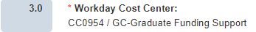

Budgetary Considerations

To locate the information needed to complete the Budgetary Considerations section of the email template, we will need to navigate back to the proposal site budget as described above.

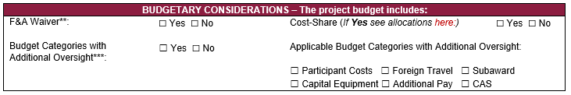

F&A Waiver

If the budget has an F&A Waiver in effect, there will be a green bar across the bottom of the budget stating F&A Waiver Approved.

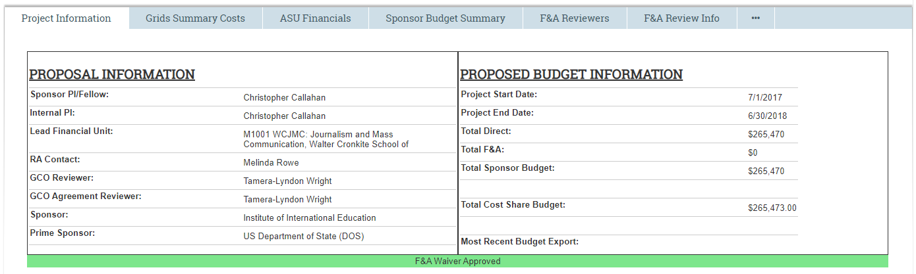

If this is not present, make sure to check if there were previous budget revisions requested by the sponsor. To see this change, click on the breadcrumbs and select the name of the proposal. Below the Proposal Information box, there will be a section for Current Budget and one for Simulation, Proposed Change, Archived and Submitted Budgets. The Simulation budget will contain the F&A waiver approval, if there is one.

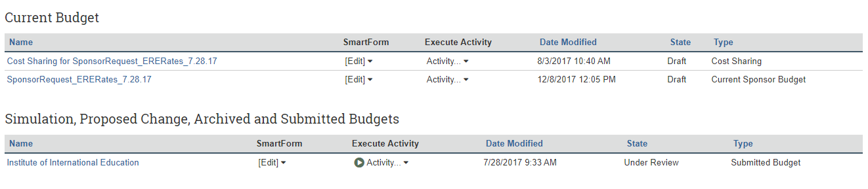
This can also be verified by selecting the original proposal budget and clicking . Use the drop-down menu to select 1.3 F&A Rate Waiver Request. This smart form is only completed if an F&A Waiver was requested at proposal time. If this smart form does not exist in the budget, an F&A Waiver was not requested.

Using this information, check Yes or No in the email checklist for whether or not an F&A Waiver was processed for this budget.

Cost-Share

We can easily determine whether a proposal has Cost Share by navigating to the main FP page under the 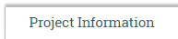 tab.

If a proposal has cost share, the cost share budget amount will be listed under the section.

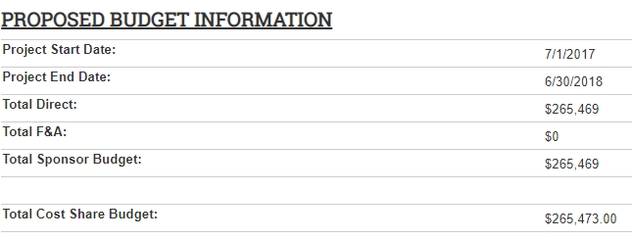
If no amount is listed, there is no cost share in the budget. Check “No” on the email checklist under Cost-Share.

If there is cost share in the budget, a link to the cost share allocation’s page will need to be linked to the email checklist. To do this, click on the cost share budget name listed under in the proposal site.

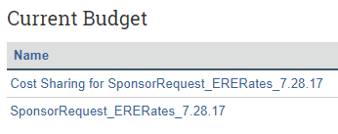

Click on . Use the function to navigate to 3.7 Cost Sharing Allocations. Select and copy the browser link and link to the “here” text in within the email checklist.

Budget Categories with Additional Oversight

To determine if any budget categories that require additional oversight were included in the proposal budget, navigate back to the main proposal budget page.

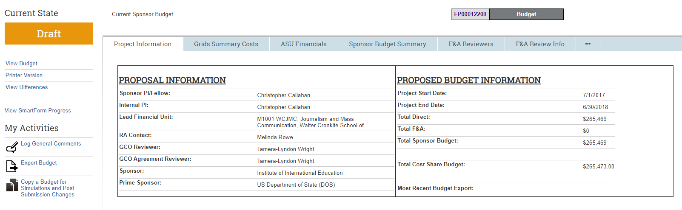

Click on the tab. If any Participant Costs are included in the budget, they will be listed in their appropriate section. Check the box for Participant Costs if this cost is listed in the budget.

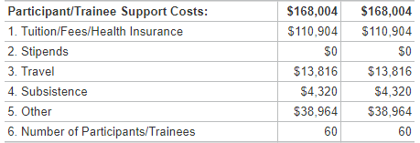

If any Foreign Travel is included in the budget, this will be listed under the Travel section. Check the box for Foreign Travel if this cost exists in the budget.

If there are any Subaward costs included in the budget, there will be funds listed under Subaward/Consortium/Contractual within Other Direct Costs. There will also be a separate Subaward budget found under the tab. Check the box for Subaward if this cost exists in the budget.

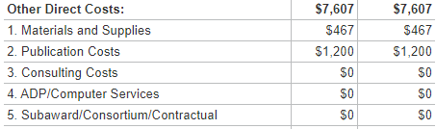

If there is Capital Equipment included in the budget, there will be funds listed under Equipment. Check the box for Capital Equipment if this cost exists in the budget.

To determine if there are any CAS exceptions in the budget, navigate to the internal budget smart forms by clicking . Use the function to navigate to 3.6 Other Direct Costs – Grid. CAS exceptions will be noted under the individual costs. If there are any costs in the budget that require CAS exceptions, check the box for CAS.

