Session Monitor Checklist

In advance of the conference:
☐ Computer updated with newest Zoom app?
☐ Zoom settings are how you want them? (e.g., background, audio, chat)
☐ Make sure you have a copy of the session slides, just in case
☐ Charge your cell phone, in case you need switch to calling in for audio

Immediately prior to the session:
☐ Fully-charged cell phone on-hand?
☐ Close all unnecessary apps, to avoid distractions and free up bandwidth
☐ Log in 10 minutes or more before session starts
☐ Make any UA or NAU presenters 'Co-host'
For Webinars, you may need to promote them to ‘Panelist’ before you can make them a ‘Co-host’
☐ Confirm that Closed Captioning is turned on. Session monitor must keep CC on throughout session.
☐ Allow screen-sharing*
☐ For Meetings, allow participants into the session from the waiting room
☐ For Meetings, mute anyone who might have inadvertently unmuted themselves.
Note: participants will come in muted and with video off by default
☐ Reorient yourself to meeting controls
If you don’t see a specific button/action, check ‘More’

Starting the session:
☐ Click 'Start Webinar'*** if you are monitoring a webinar that is in ‘Practice’ mode
☐ Confirm that red recording indicator is present at top
☐ Promptly at start time, kick-off the session
☐ welcome participants
☐ go over housekeeping items
☐ introduce presenters, if applicable

During the session:
☐ For Meetings, mute participants, as needed
☐ For Meetings, remove disruptive participants, as needed (hopefully not needed!)
☐ Monitor the chat box and/or Q&A box
Note: People joining/re-joining a meeting are not able to see anything entered in the chat prior to joining
☐ When presenters are ready to address questions, read them aloud (for the recording)
☐ Launch and End Polls***, if needed
- Troubleshooting during the session:
__Trouble hearing: call in on a phone, disable headset or computer speakers
__Low bandwidth? Turn off video
__If basic troubleshooting doesn’t fix the issue:
Have the participant call RTS at 480-965-9065 Ext 1 for technical support.

End of session:
☐ Thank presenters, remind participants to take survey at end of day
☐ Make note of questions that aren’t answered in the session

*SCREEN SHARING
MEETING:
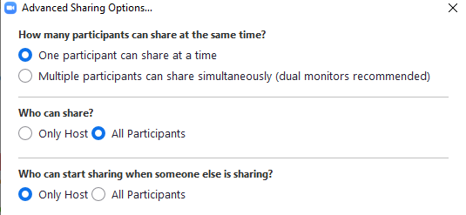

WEBINAR:
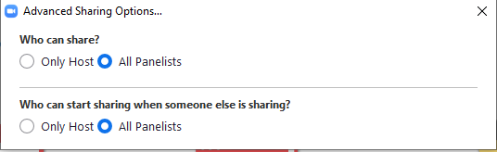

**TO START A WEBINAR IN PRACTICE MODE:
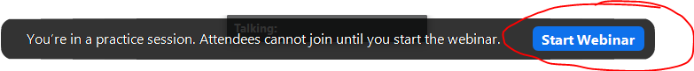

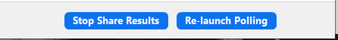
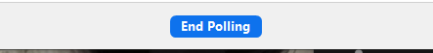
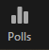
***POLLS

