U-CHEck

Purpose

A unit-level check, or U-CHEck, is a targeted review of the Funding Proposal in ERA designed to identify and remove any administrative roadblocks that can prevent PIs from starting work on a sponsored project. U-CHEck can be performed at any time prior to the activation of the award. However, we should attempt to complete the process:

- 60 days before the expected start of the project (depending on size and complexity); or
- As soon as ASU receives a Post-Submission request from the sponsor

Using the Navigation Pane

To use the Navigation Pane in Word, click on the tab at the top of this document. Check the box for under the Show section.

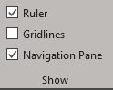

To jump from one section of the document to another using the Navigation Pane, just click on the section you want to view in the pane.

Identifying Proposals for U-CHEck

U-CHEck Calendar

Students will start the U-CHEck process as follows:

When? | Tim  Proposals with start dates: | Luis  Proposals with start dates:
1st week of October | 10/01/2019-10/31/2019 | 11/01/2019-11/31/2019
1st week of December | 12/01/2019-12/31/2019 | 01/01/2020-01/31/2020
1st week of February | 02/01/2020-02/29/2020 | 03/01/2020-03/31/2020
1st week of April | 04/01/2020-04/30/2020 | 05/01/2020-05/31/2020
1st week of June | 06/01/2020-06/30/2020 | 07/01/2020-07/31/2020
1st week of August | 08/01/2020-08/31/2020 | 09/01/2020-09/30/2020

Using the U-Check Proposal Overview Tab in Tableau

Instructions are included below but you can also watch the video “U-CHEck Tableau Part 1” located under Dropbox (ASU)\RAS Team Manual\RAS Post-Award Processes and Resources\RAS\U-CHEck\Videos

- Log in to the Proposal U Check Tableau Report via this link.
- In the “U-Check Proposal Overview” tab, click on the “RA” filter located on the left side of the screen and uncheck the (All) option
- In the “RA” filter, select the following by doing a search by last name:
  - Valerie Keim
  - Elise Miller
  - Sarah Moser
  - Samantha Munguia
  - Darci Parsley
  - Melinda Rowe
- From the “Proposal Status” filter, uncheck the box for “At-Risk Request”.
- Update the “Start Date” filter according to the U-CHEck Calendar by clicking directly on the date:
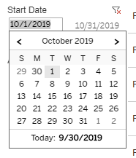

- Click on the 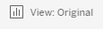 button located at the top of the screen.
- In the textbox the name of this view using the following format “UCHEck Month Year – Your Initials” and click save.
- Once you the filtered report, navigate to the below folder and open the appropriate email template:

Proposal Status Verification for FP000XXXXX (Action Required).msg
For proposals in the following status: “Submitted – Pending Sponsor Acceptance”, “Award Anticipated”, etc.

USE FOR AGREEMENT UNDER REVIEW ONLY - Verification for FP000XXXXX (Action Required).msg
For proposals with a status of “Agreement Under Review” Only.

As you gather the information below, you’ll enter the information into this template which will later be sent to the PI.

Dropbox (ASU)\RAS Team Manual\RAS Post-Award Processes and Resources\RAS\U-CHEck

Using the Proposal Status Verification Template

You can also watch the video “U-CHEck Part 1” located under Dropbox (ASU)\RAS Team Manual\RAS Post-Award Processes and Resources\RAS\U-CHEck\Videos

Using the U-CHEck report results, locate the appropriate Funding Proposal in ERA and update the Proposal Status Verification template as follows:
- Update the Subject line with the correct FP number
- Update the greeting to include the PIs name
- Update the proposal information table as follows:
  - Enter FP ID
  - Enter Sponsor
  - Enter Title
  - Enter Proposal Status
  - Enter Anticipated Start Date.
- Link the following information to the relevant proposal sections of the Funding Proposal (FP) in ERA:
  - In the proposal information table, link the FP ID to Funding Proposal Site in ERA.
  - Under the “All Projects” section, link to the allocations section of the Funding Proposal Site in ERA.
- Enter the PI’s address on the “To” line of the template.
- Enter ras@asu.edu on the CC line.

List of PIs You Should Not Email
RAS works with numerous high-profile faculty and investigators. For that reason, the Proposal Status Verification email should NOT be sent to the following:

- Sethuraman Panchanathan
- Tamara Deuser
- Mark Naufel
- Peter Byck
- Michael Thompson
- Gary Marchant

For proposals that list any of the individuals above as PI, check with assigned RAS RA to request an alternate contact.

Pasting Text into the Email Template

When pasting text into the email template, make sure to select paste the text as text only. This will ensure that the template’s formatting will remain the same. You can do this in two ways:

- Select the text you want to replace in the template. Right-click and select the last option of the Paste menu called Keep Text Only.
- Select the text you want to replace in the template. Press Ctrl + V on your keyboard to paste the copied text into this area. Click on the (Ctrl) Paste Options icon that appears after the text is pasted. Select Keep Text Only from the paste menu.

Managing PI Responses to Proposal Verification Status

When PI Does Not Respond

If PI does not respond to request for Proposal Verification, follow up weekly on the date the original email was sent. You will only to follow-up three times after the original request.

When PI Confirms Proposal is No Longer Under Consideration

- If a PI confirms that a proposal is no longer being considered for funding, acknowledge the PIs email by replying with the following message with CC to RAS@asu.edu:

Thank you for the information. We will submit a request to ORSPA to update the status of your proposal in ERA. The update should be completed within the next 5 business days.

- Click on the link to the Funding Proposal in ERA included in the email message to access the FP site:
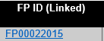
- Once in the FP site, click on 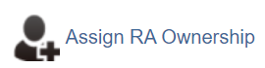
- A new window will open showing you as the New RA Owner, click OK.
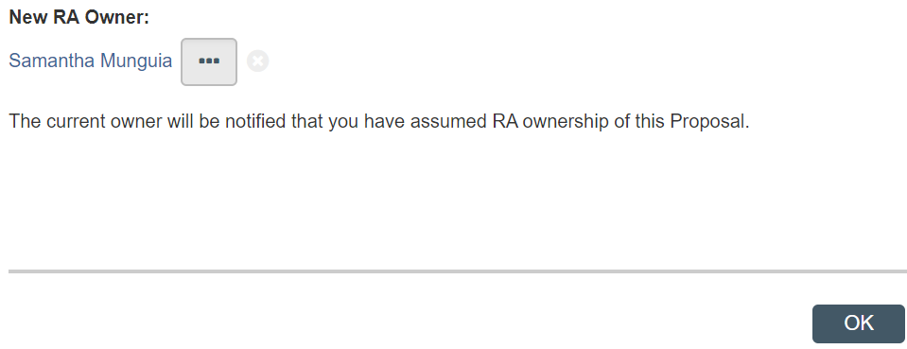
- Click on 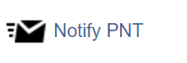
- In the new window, select Other under the section labeled “Indicate the required document review”
- In the text box, enter the following message:

Per the PI, this proposal is no longer being considered for funding (see attached). Please update proposal status.

- Attach the email from the PI
- Click OK.
- Return RA ownership to the assigned RA by running the

When PI Confirms Proposal is Still Under Consideration
If the PI confirms that the proposal is still under consideration, move on to U-CHEck Part I.

U-CHEck Part I

- If a PI confirms that a proposal is no longer being considered for funding, acknowledge the PIs email by replying with the following message with CC to RAS@asu.edu:

Thank you for the information. We will start our internal review of the Funding Proposal in ERA to ensure a smooth award activation process once the Notice of Award is Received. We might contact you if any additional information is required.

At this time, will you require an at-risk account while you wait for the official award from the sponsor?

- If the PI requires an at-risk account, forward the email chain to the RAS@asu.edu and update the subject line of the email as follows:

Original Subject | Proposal Status Verification for FP00022015 (Action Required)
Updated Subject | FOR ASSIGNMENT: At-Risk Request for FP00022015 (Action Required)

